Assignment 1: Running your First Algorithm
9/8/26
Chris Grimm

Details

Task 1) Review Oracle Interface tutorial
https://docs.oracle.com/javase/tutorial/java/concepts/interface.html
Deliverable: confirm finishing the tutorial and submit any code you wrote.
See
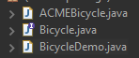
Task 2) Prepare and Clone the thinkdatastructures repo.
This includes a few tasks that you might have done before:
1-Do you have eclipse? (If not install eclipse or any JAVA IDE) https://www.eclipse.org/downloads/
2-Do you have a github user? If not create a github user! https://www.youtube.com/watch?v=w3jLJU7DT5E
3- the code examples are stored in
http://thinkdast.com/repo.
4- fork the repository (what is a repository)? (from the fork button)
5- clone the repository (shown in lab)
(note: if you have not taken SENG210 yet, you can skip the step and just copy the code for each example we cover from the source (src) folder manually. So you can jump to step 6)
A- access Git perspective (from eclipse: window\perspective\open perspective\other\Git
B- clone a new repo (under git repositories view-->clone new repo button --> copy your clone link taken from github)
C- Import new project from repo. (right click thinkdatasturctures cloned repo, import project)
Deliverable: link to forked repository
https://github.com/cgrimm25/ThinkDataStructures-Java
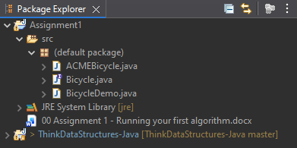
Task 3) for simplicity, we will test SelectionSort.java as a separate project.
1-create a new project and copy the SelectionSort.java code
2- test the code by running the project
Deliverable: screen shot your project output
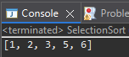
3- Update the code to read the array contents from a text file. The size limit expected is less than 100,000.
4- Measure the performance of selection sort using the library of your choice. Basically, you are looking to measure how long does the code take to run (sort the array). one example can be found here
http://tutorials.jenkov.com/java-date-time/system-currenttimemillis.html
https://jenkov.com/tutorials/java-date-time/time-measurement.html
5- Run selection sort for various array sizes (using the same file) and record the running times (hint: make sure there are not print statements included in the chunk of code you are measuring, so add any prints you need AFTER you stop measuring the time, otherwise the output time will be part of the algorithm measurement - which we do not want here - printing takes the computer much more time compared to processing
Deliverable: Code + result table for 5 different sizes
See SelectionSort.java
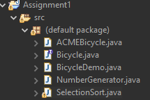
Before I called NumberGenerator
Array Size (n) | Execution Time (ms)
20,000 | 180
40,000 | 663
60,000 | 1318
80,000 | 2232
100,000 | 3422

After I added call to NumberGenerator
I was able to shave off some time. Saving more time as I processed bigger data sets.
Array Size (n) | Execution Time (ms)
20,000 | 136
40,000 | 467
60,000 | 1064
80,000 | 1848
100,000 | 2797

